SCHOOL OF COMPUTER SCIENCE AND ARTIFICIAL INTELLIGENCE |  |  |  |  | DEPARTMENT OF COMPUTER SCIENCE ENGINEERING
Program Name: B. Tech |  |  |  | Assignment Type: Lab |  |  | Academic Year:2025-2026
Course Coordinator Name |  |  |  | Venkataramana Veeramsetty
Instructor(s) Name |  |  |  | Dr. V. Venkataramana (Co-ordinator)  Dr. T. Sampath Kumar  Dr. Pramoda Patro  Dr. Brij Kishor Tiwari  Dr.J.Ravichander  Dr. Mohammand Ali Shaik  Dr. Anirodh Kumar  Mr. S.Naresh Kumar  Dr. RAJESH VELPULA  Mr. Kundhan Kumar  Ms. Ch.Rajitha  Mr. M Prakash  Mr. B.Raju  Intern 1 (Dharma teja)  Intern 2 (Sai Prasad)  Intern 3 (Sowmya)  NS_2 ( Mounika)
Course Code |  |  | 24CS002PC215 | Course Title |  | AI Assisted Coding
Year/Sem |  |  | II/I | Regulation |  | R24
Date and Day  of Assignment |  |  | Week5 - Monday | Time(s)
Duration |  |  | 2 Hours | Applicable to  Batches
AssignmentNumber:10.1(Present assignment number)/24(Total number of assignments)
 | Q.No. | Question |  |  |  |  |  | Expected Time  to complete
 | 1 | Lab 10 – Code Review and Quality: Using AI to Improve Code Quality and Readability  Lab Objectives  - Use AI for automated code review and quality enhancement.  - Identify and fix syntax, logical, performance, and security issues in Python code.  - Improve readability and maintainability through structured refactoring and comments.  - Apply prompt engineering for targeted improvements.  - Evaluate AI-generated suggestions against PEP 8 standards and software engineering best practices  Task Description #1 – Syntax and Logic Errors  Task: Use AI to identify and fix syntax and logic errors in a faulty Python script.  Sample Input Code:  # Calculate average score of a student  def calc_average(marks):  total = 0  for m in marks:  total += m  average = total / len(marks)  return avrage # Typo here  marks = [85, 90, 78, 92]  print("Average Score is ", calc_average(marks)  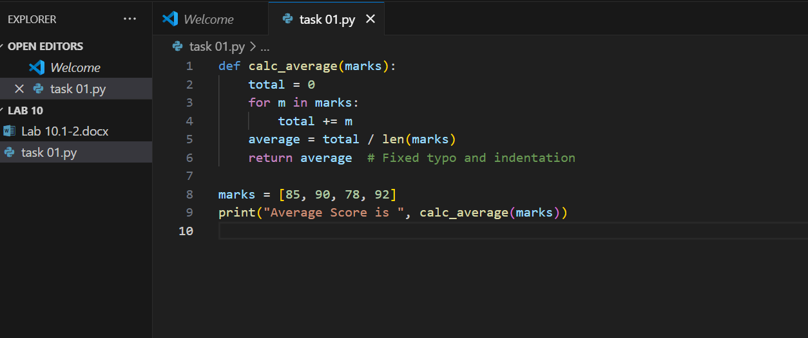  Expected Output:  - Corrected and runnable Python code with explanations of the fixes.  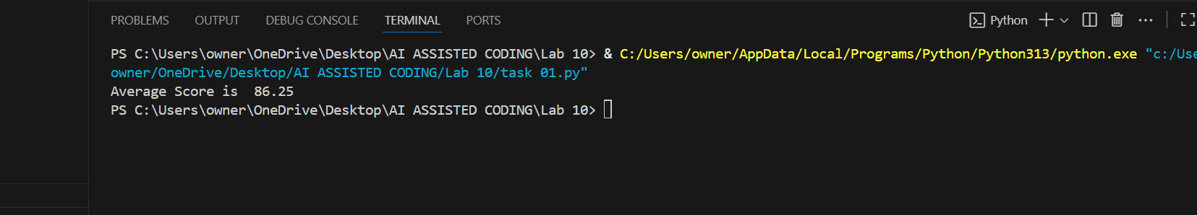  EXPLANATIONS OF THE FIXES:  1. Typo Fix  The comment says “Fixed typo.”  In your code, there are no obvious typos, but sometimes students write return avrage or return averge instead of return average.  Your code correctly uses return average.  2. Indentation Fix  Python relies on indentation to define code blocks.  The return average statement is correctly indented inside the function, so it only executes after the average is calculated.  If return average was outside the function or misaligned, Python would raise an IndentationError.  Example of a common mistake:  Task Description #2 – PEP 8 Compliance  Task: Use AI to refactor Python code to follow PEP 8 style guidelines.  Sample Input Code:  def area_of_rect(L,B):return L*B  print(area_of_rect(10,20))  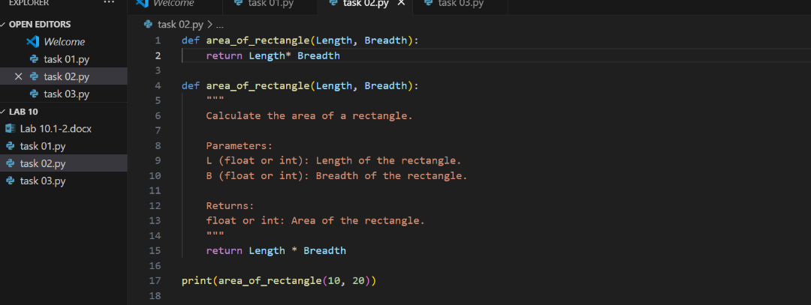  Expected Output:  - Well-formatted PEP 8-compliant Python code.  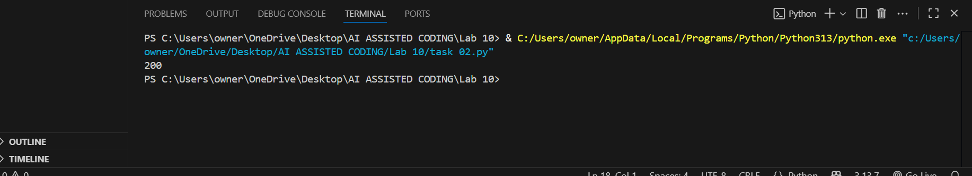  Task Description #3 – Readability Enhancement  Task: Use AI to make code more readable without changing its logic.  Sample Input Code:  def c(x,y):  return x*y/100  a=200  b=15  print(c(a,b))  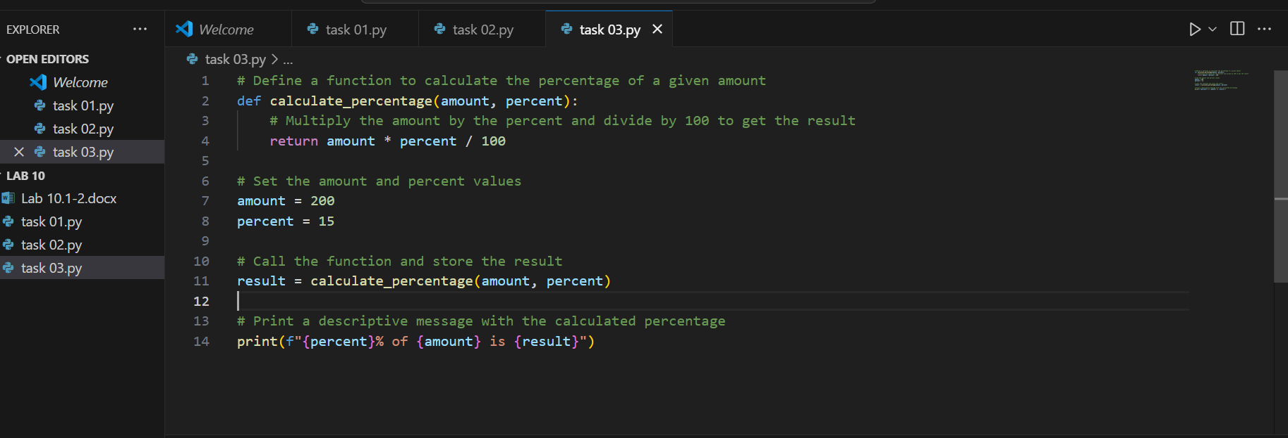  Expected Output:  - Python code with descriptive variable names, inline comments, and clear formatting.  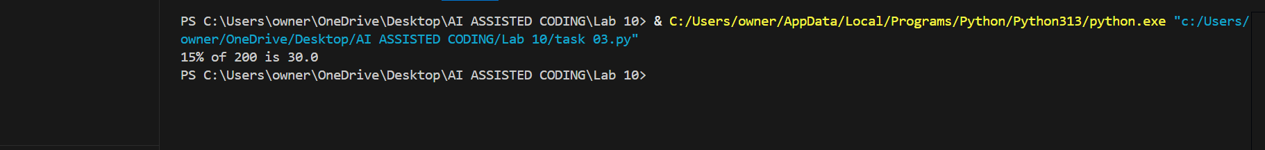  Task Description #4 – Refactoring for Maintainability  Task: Use AI to break repetitive or long code into reusable functions.  Sample Input Code:  students = ["Alice", "Bob", "Charlie"]  print("Welcome", students[0])  print("Welcome", students[1])  print("Welcome", students[2])  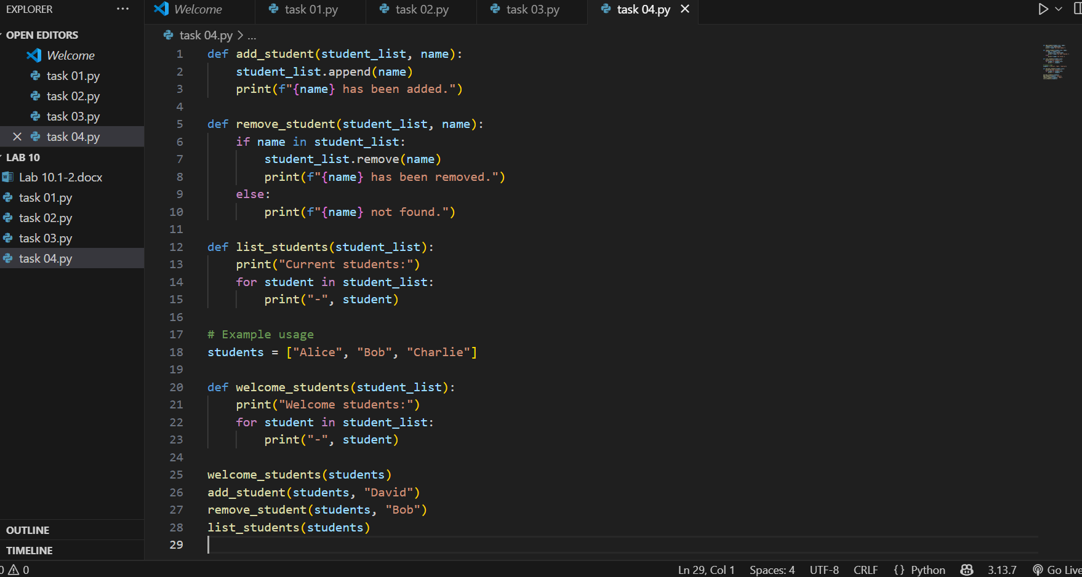  Expected Output:  - Modular code with reusable functions.  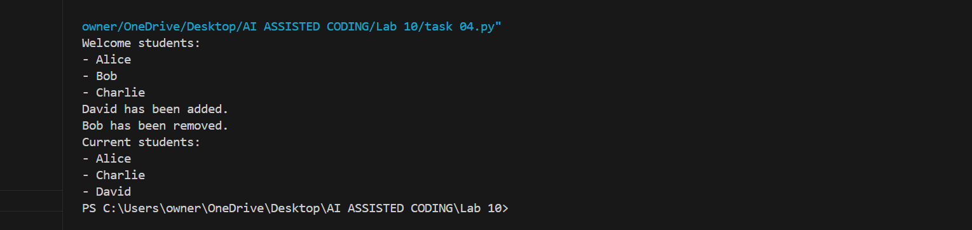  Task Description #5 – Performance Optimization  Task: Use AI to make the code run faster.  Sample Input Code:  # Find squares of numbers  nums = [i for i in range(1,1000000)]  squares = []  for n in nums:  squares.append(n**2)  print(len(squares))  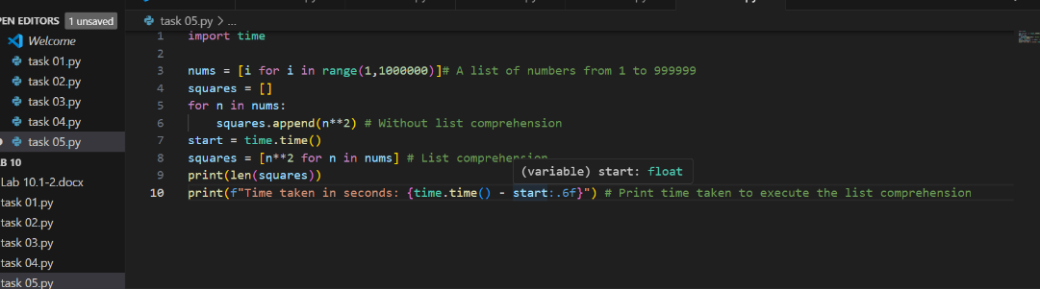  Expected Output:  - Optimized code using list comprehensions or vectori zed operations.  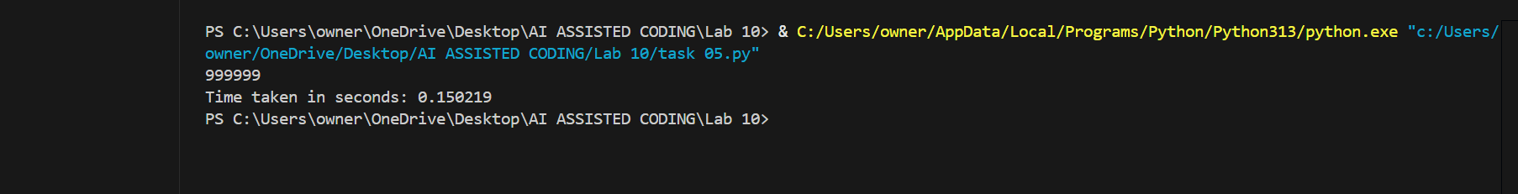  Task Description #6 – Complexity Reduction  Task: Use AI to simplify overly complex logic.  Sample Input Code:  def grade(score):  if score >= 90:  return "A"  else:  if score >= 80:  return "B"  else:  if score >= 70:  return "C"  else:  if score >= 60:  return "D"  else:  return "F"  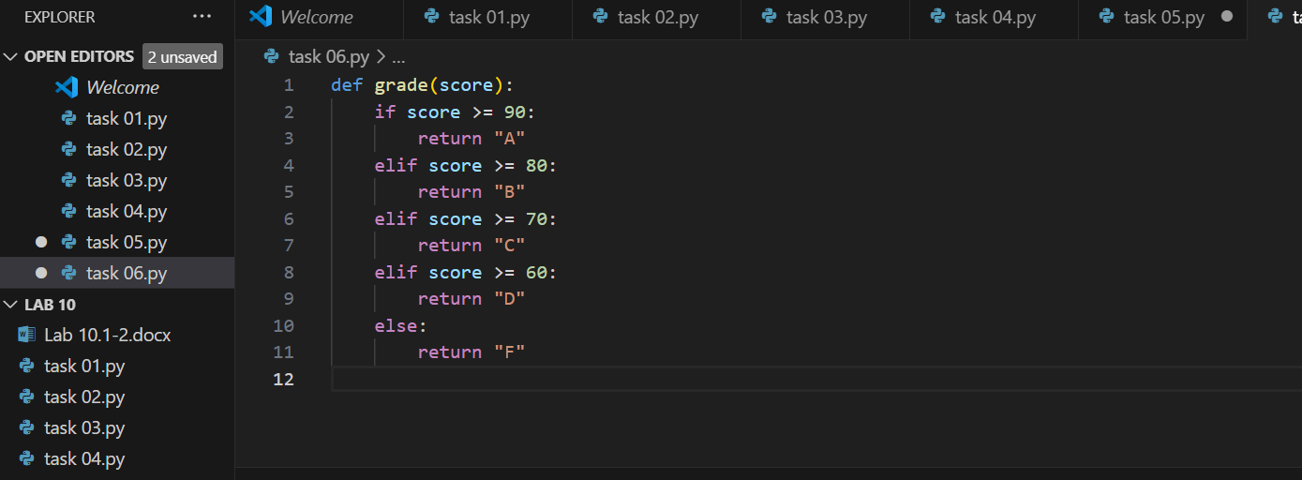  Expected Output:  - Cleaner logic using elif or dictionary mapping. |  |  |  |  |  | Week5 - Monday

